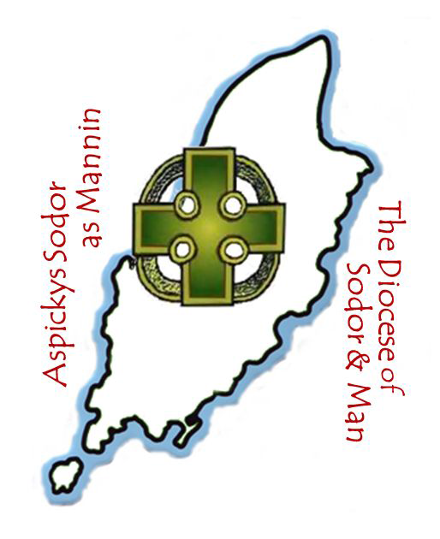

Continuing Ministerial Development
Programme
2020
TOGETHER MAKING CHRIST VISIBLE

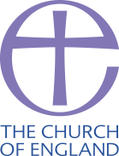

The Convocation of Clergy in this Diocese took place in Whitsun week every year as an Ordinance of Bishop Thomas Wilson in 1703. This annual Convocation was abolished in 2010 and the Bishop was granted powers to summon Convocation of all public ministers annually and at his discretion. The monthly CMD is an extended Convocation and is mandatory for beneficed and licensed clergy and readers, which is why all are expected to prioritize all CMD sessions in their diaries. Any readers and clergy who are licensed or beneficed who are prevented from attending a session are asked to apologise to the Bishop’s office in advance. CMD is optional for PTO ministers so we would not expect to receive their apologies for absence but they are more than welcome.
The normal format of meetings on Thursday evenings is
19.30 Prayer
19.40 Part one
20.30 Notices and Refreshments
20.45 Part two
21.30 Concluding prayer

In Holy Week we gather for the Chrism Eucharist at the Cathedral at 12 noon on Maundy Thursday.
Our ecumenical partners in ministry are more than welcome to join in in any of the CMD sessions and the Quiet Day.
The 2020 programme is designed for all ministers, though lay and ordained may meet separately for part of any of the sessions.
Personal CMD. £300 is set aside by the DBF from the Shared Ministry Fund annually for each licensed/beneficed (not PTO) lay or ordained minister, £200 of which will be available to each individual for personal ministerial development based on your Ministerial Development Review. This must be approved by the CMD Officer and may be saved for a maximum of 2 years (£350 maximum for 2020). A new application process will be in place for 2020.
While training is funded from the CMD allocation, I welcome requests for use of the Bishop’s Discretionary Fund in any cases of hardship or other exceptional causes: please contact my office.
+ Peter
CONTINUING MINISTERIAL DEVELOPMENT 2020
Provisional Dates
7.30-9.30pm normally at St Ninian’s, Douglas

16 January 2020 Exploring Rural Ministry- Revd Dr Mark Betson; National Rural Officer for the Church of England

20 February 2020 How we can support people with hearing difficulties- Lucy Buxton from the Manx Deaf Society

19 March 2020 Practical tips on how to start youth ministry- Stasi Tregartha
Parish Administration- The Bishop and Archdeacon

Date TBC 10am-4pm, the Cathedral- Quiet Day with Fr John Gribben CR, lunch included.

9 April 2020 12pm- Chrism Eucharist at the Cathedral followed by lunch

21 May 2020 A talk by Archbishop Angaelos; Bishop of the Coptic Orthodox Diocese of London

18 June 2020 Considering the Environment- The Bishop

16 July 2020 The Worldwide Church- Bishop Douglas Fisher, Diocese of Western Massachusetts and Bishop John Lupaa, Diocese of the Rift Valley in Tanzania

17 Sept 2020 Social Enterprise- The Dean

15 Oct 2020 Mental Health Awareness- Ali Vondy from Manx Minds

19 Nov 2020 Exploring Advent- The Bishop

As ministers of the Diocese of Sodor and Man
we are committed to
- making disciples
- refreshing disciples
- sustaining disciples

As the Diocese of Sodor and Man
we are committed to work and pray for growth in
- spiritual life in Christ
- understanding and practice of the faith
- numbers
- youthfulness
- ecumenical collaboration
- world-church awareness

The Ministry Conference Prayer of Commitment
God our Father, in the name of Christ
and in the power of your Spirit,
we commit ourselves to you and one another,
to live, work, and pray as one body in Christ,
to trust each other as fellow workers in your Church,
and to give ourselves with body, mind, and spirit
to the ministries to which you have called us.
Give us vision, give us courage, and give us joy,
that the world may believe that Jesus Christ is Lord,
to your eternal glory.
Amen.

