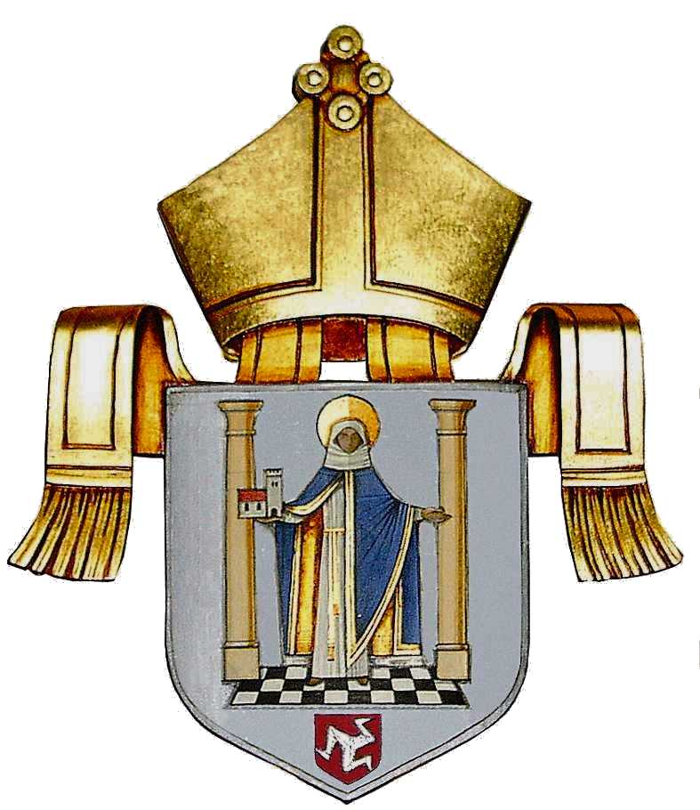
The Diocese of
Sodor and Man

Together making Christ visible

DIOCESAN VISION 2022-24

The Three Strategic Priorities:

Renewal

Faithfulness

Generosity

‘Anointed and Rooted in God, we work together for Renewal, which will be visible in Faithfulness and Generosity’

Renewal

The Diocese of Sodor and Man will:

- Renew itself spiritually and in its liturgy to deliver the mission of the Church, specifically in the flourishing and growth of every parish.

- Engage in a process of spiritual renewal at the level of:

- individuals;
- congregations;
- Parishes;
- Mission Partnerships.

- Renew our engagement with wider society and our own local communities as a supportive and interested presence.

- Renew ourselves as a ‘Servant Church’ in volunteering in the service of God and in addressing the concerns and serving the needs of our neighbour and of the community – needs that are social, cultural, economic, environmental, educational, as well as spiritual.

- Renew our commitment to ‘Social Liturgy’ from a Christian scriptural base to progress social justice through social action, working together towards the world that is God’s will for us.

- Renew ourselves in support to all are suffering due to poverty, unemployment, bereavement, ill health, disability, and marginalisation from mainstream society; and in support to our global neighbours who suffer from war, natural disaster, food insecurity, environmental degradation and climate change.

- Renew our commitment to the vulnerable, and continue to build and embody the highest standards of safeguarding.
Faithfulness

The Diocese of Sodor and Man will:

- Encourage and support all its people in their journey of faith, that it may be renewed, deepened and developed.

- Pay particular attention to the quality of our worship, liturgy, music and preaching.

- Continue the implementation of ‘Setting God’s People Free’ to enable lay Christians to share their faith with others in aspects of life beyond churches in their places of work, study, recreation, and community.

- Develop opportunity for people to study our faith and scriptures together.

- Demonstrate a particular concern for children and young adults, supporting and encouraging them to:

- give attention to the spiritual dimension of their lives;
- recognise the importance of faith in making choices for their lives, and in understanding broader ethical, social and environmental concerns;
- help them to ‘own’ their faith.

- Contribute to education, training and learning within and beyond the Diocese, with particular reference to Emmanuel Theological College and its potential for further levels of theological and ministerial education.

Generosity

The Diocese of Sodor and Man will:

- Cultivate Generosity as our defining and distinctive characteristic.

- Embed, embody and exemplify Generosity at the personal and corporate level, with the specific intention to:

      - provide deep personal, pastoral and spiritual support to one another;
      - share wisdom, experience and blessings across congregations and parishes;
      - affirm imaginative and creative thinking;
      - promote leadership and confidence at local level.

- Promote confident use and investment of our resources of people, buildings and finance.

- Take compassionate care of ourselves and others, that we may grow and flourish in mind, body and soul.

- Take compassionate care of the Environment, actively supporting diocesan environmental initiatives.

- Offer generous use of our buildings and premises to the local and wider community as shared resources for active engagement and ‘social liturgy’.

- Support our diocesan and financial resilience by generous giving (including the promotion of Digital Platforms), investment, local initiative at personal and parochial level, intentional stewardship, collaboration and partnership.

