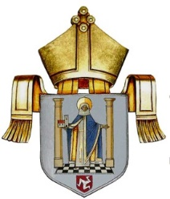

Retreats
DIOCESE OF SODOR AND MAN RETREATS
It is expected that clergy will take at least an annual retreat. The form and pattern of the retreat will vary but during a year full-time clergy should set aside the best part of a week for this activity (not including Sunday).
Information relating to Retreat Houses can be obtained from Rev Irene Cowell or online from the Retreat Association website.
We also now have access to Thie Dy Vea Retreat Centre, Peel. www.retreathouse.im
This will not be considered as leave. In accordance with the guidance on Parochial Expenses of the Clergy PCCs should be prepared to meet the cost of any bona fide fees and expenses.
Personal CMD allowance may be used for this purpose but not in consecutive years.
Rev Irene Cowell
Diocesan Director for CMD
Reviewed January 2022

