|  |  |
| --- | --- |
| Your guide to CHURCH retirement LIVING  January 2023  This guide gives an overview of our retirement housing options for people who have served or worked for the Church. | |
|  |  |

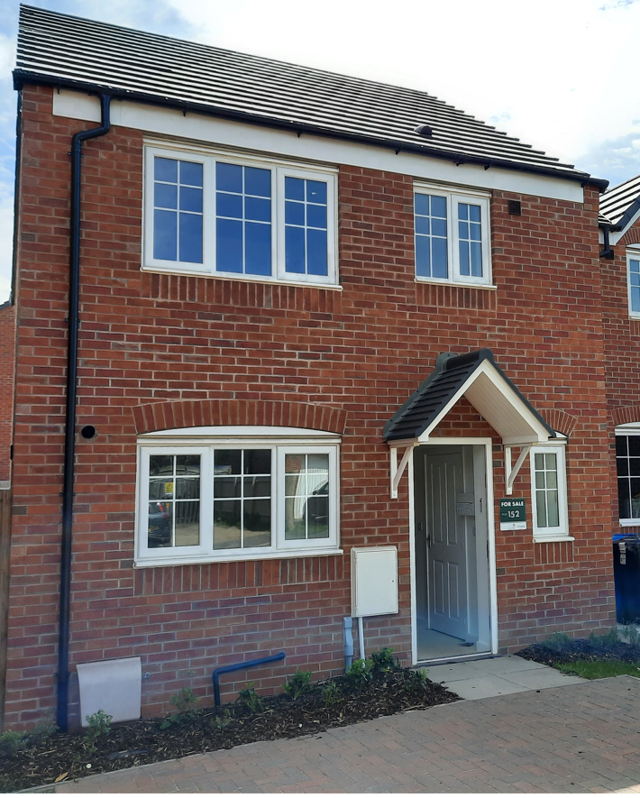

## Introduction

**2**

We recognise that retiring from ministry is a significant step. For many clergy, it comes with the need to make a move to a different home, parish and community.

We offer support to clergy who need to make a housing move at or in retirement through a range of housing services.

**How we can help you**

In summary, we can offer,

* the opportunity to start planning your retirement housing up to five years before retirement
* a choice of Church retirement housing options with us and information and guidance around what is available with other providers, helping you to make the best choice for your retirement.
* clear, timely and accessible information and guidance to enable you to make informed decisions,
* a single point of contact, to help you as you explore the right option for your retirement
* support in accessing any additional financial support that you may be entitled to during retirement,
* advice, information and support if your housing needs change during retirement - for both existing and new customers.

**Overview of our service**

**3**

**An introduction to Church Retirement Living**

We offer two forms of housing to retired clergy and their spouses/partners:

1. Our **seven community living schemes** are situated in wonderful settings across the country, offering the benefits of self-contained flats situated in vibrant, lively communities. Our community living schemes offer more than just ‘bricks and mortar’ with facilities designed to maintain independence as people grow older.
2. We provide a range of **properties to rent** across England and Wales. Available 2-3 bedroom properties are advertised regularly throughout the year. Individuals, in need of modest, affordable housing, can express an interest in these properties, be invited to a viewing and then reserve a property in advance of their retirement.

The route to finding a Church retirement home is our property bulletin. All available property – whether in a community living scheme or a rental property – is advertised via the bulletin.

**We encourage anyone in need of help with retirement housing to check the property bulletin regularly.**

The bulletin offers you a window into what is available, showing property location, layout, local facilities etc. It is also the very best way for you to consider housing costs (rent, council tax, and utility costs). New properties are added throughout the year to the bulletin as they become available.

*More detail on the Church Retirement Living options with us are provided on the following pages.*

**Supporting you to look at all your housing options**

**From the earliest stage of our conversation with you, we will encourage you to look at all your housing options, including with a range of other providers.**

We encourage you to look at all options, as we want you to find the right option for you for your retirement, and sometimes that won’t be with us. For instance, you might be keen to explore home ownership options. Or, to move to a very specific part of the country, where there aren’t many available Church properties.

As part of our process, we will provide you with information, guidance and support around the range of wider options available with other providers, including retirement living, rental and home ownership options.

Our Housing Options Service, can help

**4**

you explore these options, by sharing information what other providers offer, where they operate and how to apply.

Looking at these options, will help give you more choice to find the right option for you.

**When to apply**

We would encourage anyone who might need help with retirement housing to get in touch with us well in advance of their retirement. We accept applications for Church Retirement Living up to 5 years in advance. Why? This gives you the best opportunity to find something you want, which you can afford, and is in an area you like.

Applying early is also just as important with other housing providers.

**Who we can help**

While each Church Retirement Living option has its own eligibility criteria, including minimum type and length of service requirements, broadly all our options are open to:

* retired clergy,
* deaconesses,
* Church Army officers,
* spouses/civil partners, widows and widowers of beneficiaries,

Our Community Living schemes are also open to:

* those with non-stipendiary ministry service,
* Brothers and Sisters from Anglican religious orders,
* Licensed lay ministers
* those who receive a pension from the National Church Institutions.

**Where to start**

If you are thinking of applying for help from us, the first step is to contact our Housing team, using the details below.

We will ask you for some initial information, so we can confirm your eligibility.

Once you have got in touch, we will explain to you more about our services, and what we can offer you based on our circumstances.

More information can be found on our website: [**www.churchofengland.org/housing**](http://www.churchofengland.org/housing)

|  |  |
| --- | --- |
|  | **0207 898 1824** |
|  | [**housingservices@churchofengland.org**](mailto:housingservices@churchofengland.org) |
|  | Housing  Church of England Pensions Board  PO BOX 2026  PERSHORE  WR10 9BW |

**5**

**More detail**

**Community Living**

We own and manage seven community living schemes around the country. These are available to both newly retiring and existing customers, at any stage of their retirement. Unlike our rental properties which are designed to support clergy leaving tied accommodation, these services are available to a wider group of applicants.

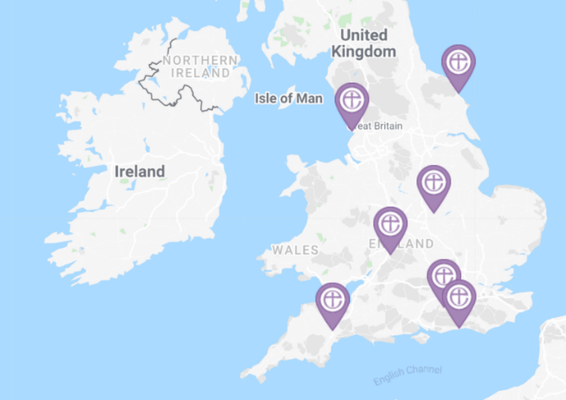

**Eligibility criteria**

We can help:

* those with stipendiary service,
* those with non-stipendiary ministry service,
* Brothers and Sisters from Anglican religious orders,
* Church Army officers,
* Licensed lay ministers
* those who receive a pension from the National Church Institutions, and
* their spouses and civil partners.

To be eligible for one of our community living schemes you (or your spouse/partner) must have at least 5 years’ service.

**Rent and service charges**

If you have savings of £16k or above, you will be expected to cover the full costs of the service; if not, you may be eligible for housing benefit. If you are a member of the clergy and have at least 5 years stipendiary service, you may be eligible for subsidised support costs.

## More detail

**6**

**Rental**

If you can’t afford to buy a property, our rental housing offers you the opportunity to rent a modest, unfurnished home that we already own, under a tenancy agreement. This would mean you could stay in our property for as long as you were able to. This is known as an Assured Tenancy.

**Eligibility criteria**

To be eligible for one of our rental properties you must:

* be (or have been) living in a ‘tied’ house during your ministry;
* have retired from active ministry within the Church
* be in need of affordable retirement housing i.e. are not able to buy a home of your own or own a residential property already
* have a minimum of 15 years stipendiary service by the time you retire, of which up to 3 years can be through a ‘House for Duty’ post.

*If both you and your spouse/partner are ordained, and together you have offered 15 years of stipendiary service through sequential appointments, we might also be able to help.*

**Our rental properties**

Our portfolio includes a range of typically 2 and 3 bedroom houses and bungalows, with some flats.

We have properties spread right across the country, albeit properties in more expensive areas (especially London), tend to be considerably smaller than in rural areas are fewer in number and only appear in the bulletin very rarely.

When making your application, you will be asked to think about a few areas you want to move to. Although our range of available properties changes relatively frequently, we can’t guarantee that we will have a particular type of property available in just the right area at just the right time. The more flexible you can be about location, the more choice you will have.

*Please note, you would need permission from your Bishop or Archdeacon if you wanted to stay within your current parish*.

Some of our properties are newly or recently built homes; others are older.

**7**

Before you move in, we will check your home, to make sure it is safe, secure, clean and in a good state of repair. In some cases, this requires just safety checks; for older properties it may include the upgrade of certain property elements and decoration. All properties are let unfurnished.

**Rent**

We charge rents for our properties that are lower than normal market rents for similar homes. Rents will be indicated on the property bulletin against each property.

It is important to note that the rent you pay will vary dependent upon the location of the property and the size of property you choose. We charge our rent on a calendar month basis and we ask you to set up a monthly direct debit for the rent charged. We increase our rents annually in April of each year, usually in line with inflation.

**Service Charges**

If your home forms part of a block of flats or is on a private estate, you may be required to contribute to some communal services that are provided by the freeholder or managing agent.

**Other expenses**

You are responsible for the council tax for your home, your utility bills including gas, electricity and water. You are also responsible for your telephone and broadband bills, along with any other household costs you incur, as well as contents insurance for your personal possessions. You would need to pay for moving costs, furnishings and white goods.

**Repairs and Maintenance**

As the landlord, we undertake repairs and maintenance of customers’ homes apart from white goods, cleaning, gardening and internal decorations, carpets and soft furnishings. Full details of our obligations as a landlord will be set out in your tenancy agreement and resident’s handbook.

**More detail**

**8**

**Exploring your options with other providers**

Sometimes finding the right retirement home will mean looking at range of different options - not just at what we can offer but also what is available with other providers.

Our team can help put you in touch with a range of other housing providers (including ones that specialise in home ownership), depending on your individual circumstances.

Supporting you to look at all your options is part of our retirement housing service. At the very earliest stages of your application, we will provide you with a **Housing Options** information booklet.

This will set out the range of options that might be available to you. We can talk through those options with you and to support you with applications to other providers. This can help some applicants who are determined to retire to a specific area, but one where we are unable to help via the property bulletin.

Of course, these options are just a guide as to what might be available to you. Having a look online around the area you want to retire to, can give more possibilities.

## More detail

**9**

**Finding your retirement home**

**How our service works**

Once you have got in touch with us and we have confirmed that you are eligible, we will arrange to meet with you, either in person, or via a video conference call, to explain more about how we can support you in exploring your retirement housing options.

In this meeting, we will discuss your application to ensure we fully understand what you are looking for, your needs and requirements. Then share the range of options that are available within the Church and potentially with other providers. This conversation should help you to start to think about the options available, and what might be the right fit for you.

After this meeting, we will add you to the circulation list for our property bulletin and we will encourage you to start looking at any options with us or with other providers that might be right for you.

Please be prepared for the fact that finding a retirement property that you can afford in a place where you want to live, takes time, and will need you to spend time looking at all of the options. After all, only you, can find the right option for you from what is available!

**Keeping in touch as you look at your options**

We don’t want you to be in a position where you are running out of time to find your retirement home. We will be in regular contact with you to discuss the options you are exploring (whether through the bulletin or with providers), and how those options work with your intended retirement date.

**Finding a Church retirement home**

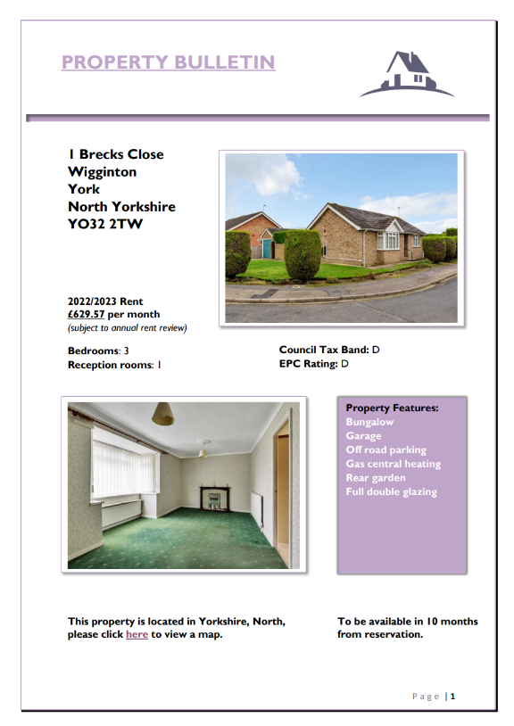All our available properties are advertised on the property bulletin, which is circulated regularly by email. Properties are listed together with their location, the rental charges, photos and a floor plan. If you see a property you like, you can then express your interest.

**Reserving a property**

**10**

If you are interested in any of the properties advertised in the property bulletin, you will be able to let us know by returning an ‘expression of interest’ form to us via email or post.

With regards to *rental* properties, if more than one applicant expresses an interest in the same property, we will prioritise viewings, based mainly on application date.

Having viewed the property and decided it is for you, it can be reserved through a simple form. You can reserve your Church planned retirement home for up to 5 years, ready to move into when you retire. If your retirement date is some years away, we may commercially let the property for a limited period. We will ensure that the property is ready for you, in line with our Lettable Standard in good time for your retirement.

If you express an interest in one of our *community living* options, a scheme manager will get in touch with you to invite you to visit and walk you through the process from there.

**Next steps**

If you would like to see if you are eligible for help with housing, or to find out more about how we could support you, please call 0207 898 1824 or email [housingservices@churchofengland.org](mailto:housingservices@churchofengland.org).